Project 2
FIR Filter Design
ECE 320
Quy Pham
Dec 04, 2008
Matlab Project 2 – FIR Filter Design

- Introduction:
In this project, we will design an FIR filter using the window function method in Matlab. This project is divided into three sections. First section will be mainly on getting familiar with the discrete-time lowpass filter by calculating the impulse response from frequency response and vise versa. Second section will be on designing lowpass, bandpass and highpass filter in Matlab and test them on audio signals. Third section contains source code of our filters.
- Result:
- Background:
- Using the inverse Fourier transform, determine the impulse response h_{lpf}[n] for the ideal lowpass filter. Make a fully-labeled sketch of this impulse response.
(on separate papers)
- FIR Filter Design via the Window Method:
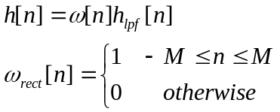
The frequency response is the convolution of the transform of the window with the ideal lowpass filter characteristic.
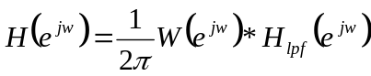
- Analytically determine the transform of the rectangular window ω_{rect}[n].
(on separate papers)
- Generate rectangular windows of length 11,51, and 101 points. Use the freqz command to compute 1024 points of the frequency response for each of these windows.
Fig.2.1
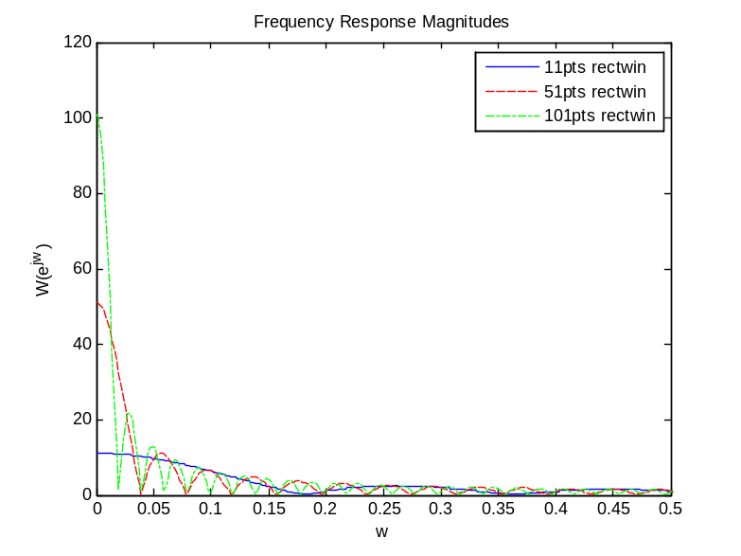
Each has its own window’s length, therefore their mainlobes are different. As we predicted in the previous part, as we increase the window’s length, the mainlobe decreases.
- In this part, we create 3 lowpass filters using the 3 windows we defined in the previous section.
- Impulse response of the 3 filters we defined.
Fig.2.2
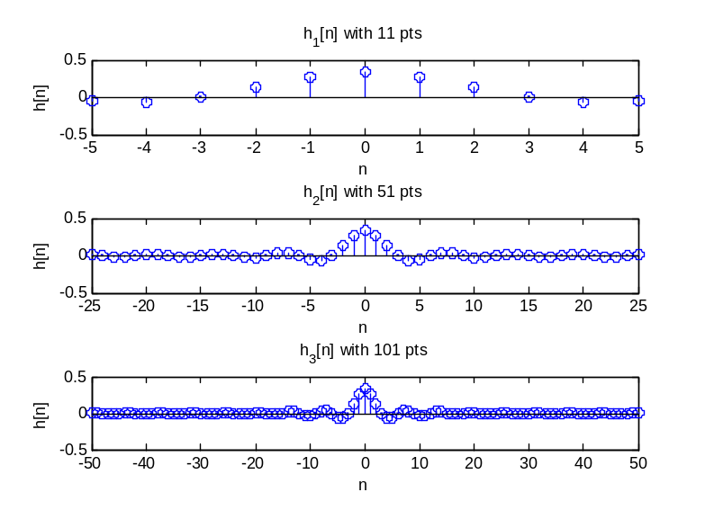
- Use freqz command to find the frequency response of the 3 filters. Plot these on 3 subplots.
Fig.2.3
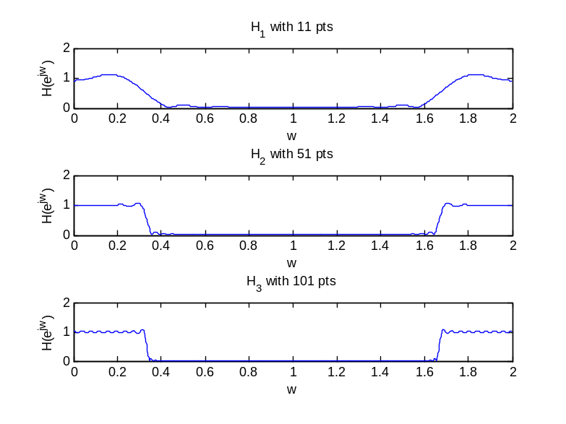
- These three frequency responses are different in the number of ripple. As we increase the window’s length, the number of ripple increases.
- Blackman window:
- Generate 3 blackman windows of length 11, 51, and 101.
Fig.2.4
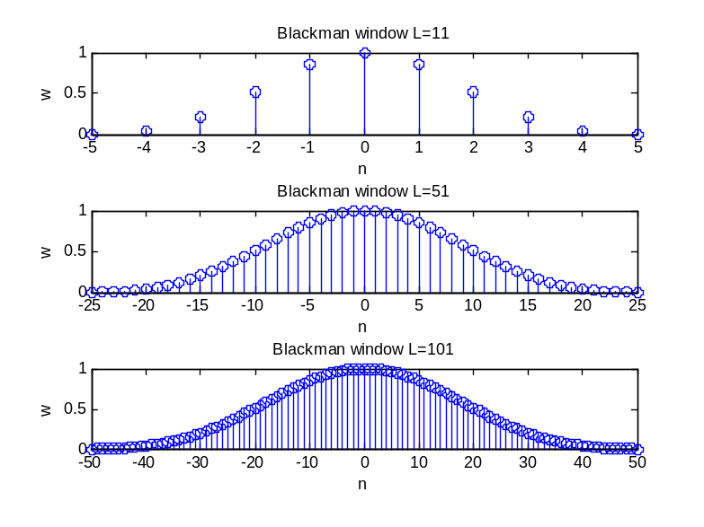
Blackman window has a curvy shape as compare to the rectangular window.
- Frequency response magnitudes of these 3 blackman windows and the 3 of the corresponding rectangular windows in comparison.
Fig.2.5
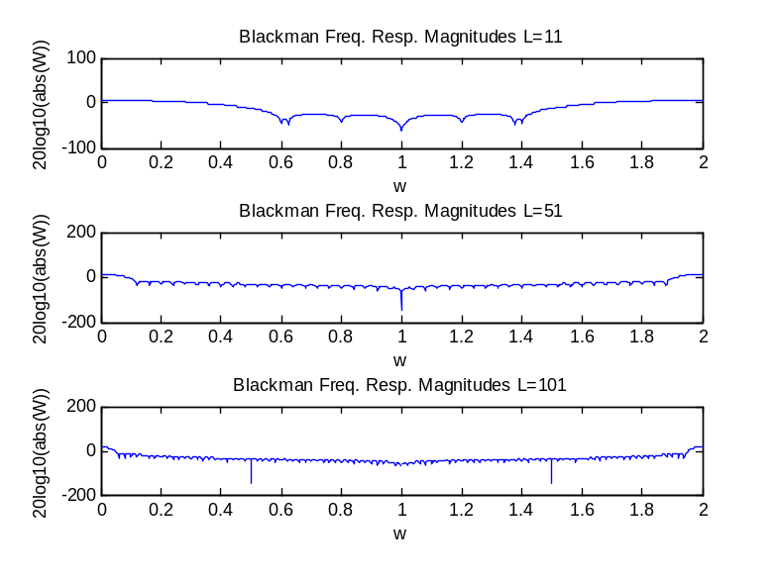
Fig.2.6
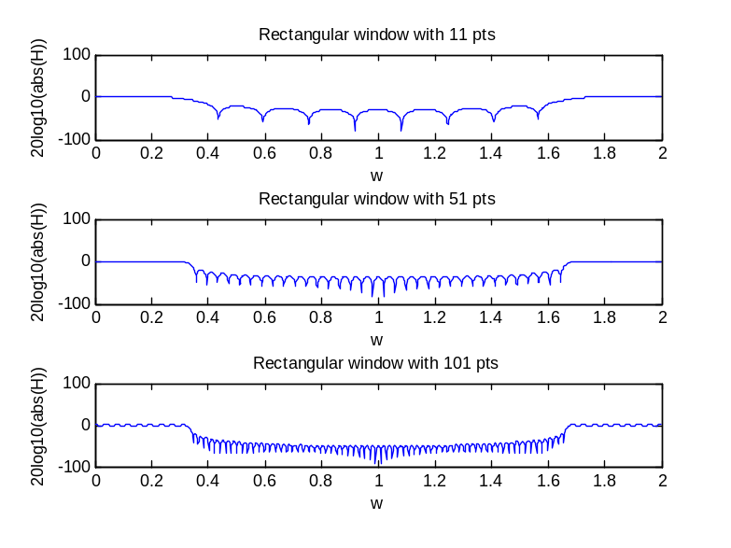

The Blackman has lower ripple as compare to the rectangular.
- Use the 3 blackman windows to design lowpass filters with a cutoff frequency of π/3 and length of 11, 51, and 101.
Frequency response magnitudes of these filters.
Fig.2.7
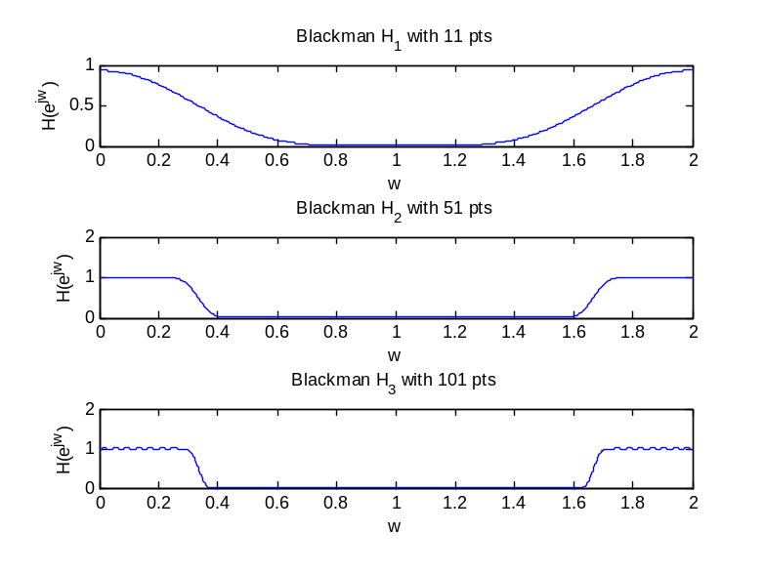
As compare to the rectangular, the Blackman is smoothier and has less ripple.
- In this part we will write a function to implement window design of lowpass filter (in Apendix)
- A few plots to prove the lowpass filter function work. The Fig.2.8 is the plot from previous part. The Fig.2.9 is generated by our lowpass filter function fir_lpf(). They produce the same results.
Fig.2.8
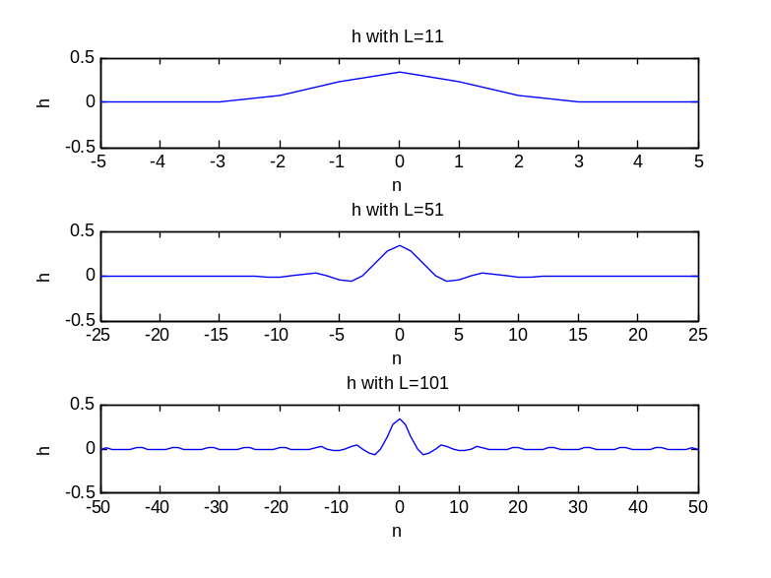
Fig.2.9
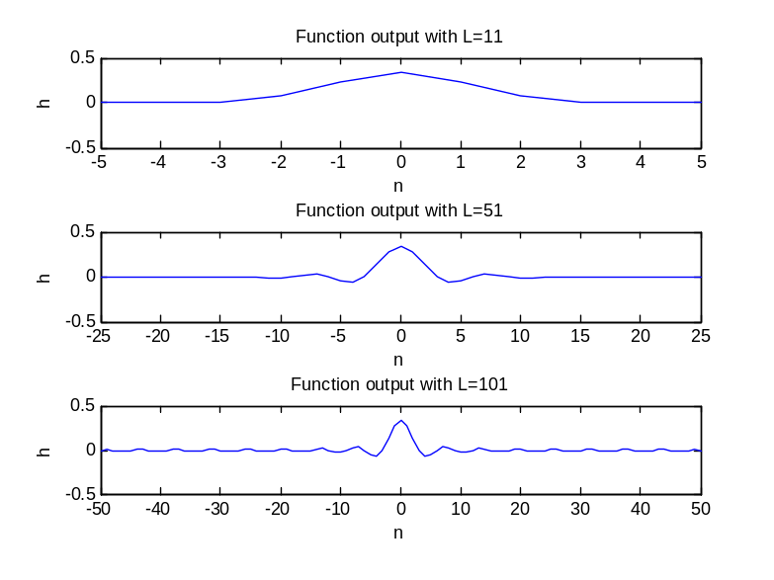
- Design of Bandpass and Highpass FIR Filters:
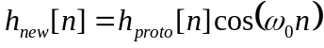
Where h_{proto}[n] is an existing prototype filter and ω₀ is a known frequency.
- Determine an analytical expression for H_{new}(e^{jw}) in term of H(e^{jw}).
(in separate papers)
- In separate papers.
- Use fir_lpf() function to design a 101-point lowpass filter with cutoff frequency π/4. Then multiply it by cos(πn) to shift and thus create a new filter.
Fig.2.10
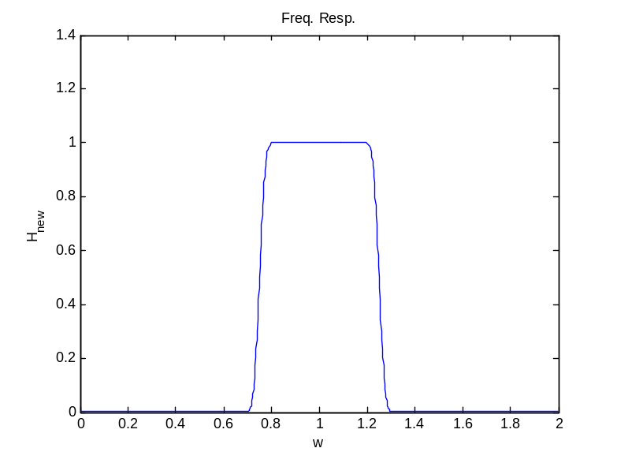
- Using the same technique described above to design a bandpass filter with the following characteristics:
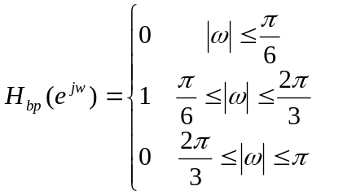

- Sketch 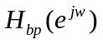for 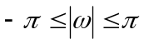 (in separate papers).
- The cutoff frequency we would choose for the prototype ideal lowpass filter to use in this design is wc=π/4, wo=5π/12.
(detail on how to calculate wc and wo is on the separate papers)
- Use the values we determined in previous part and plug-in our fir_lpf() function to generate the impulse response and the frequency response magnitude of this filter.
Fig.2.11
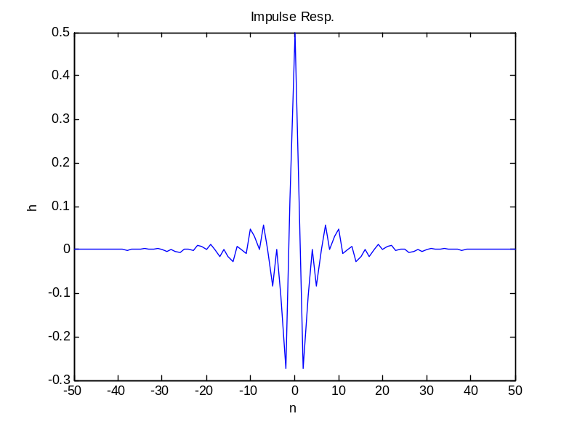

Fig.2.12. The frequency response of the bandpass filter.
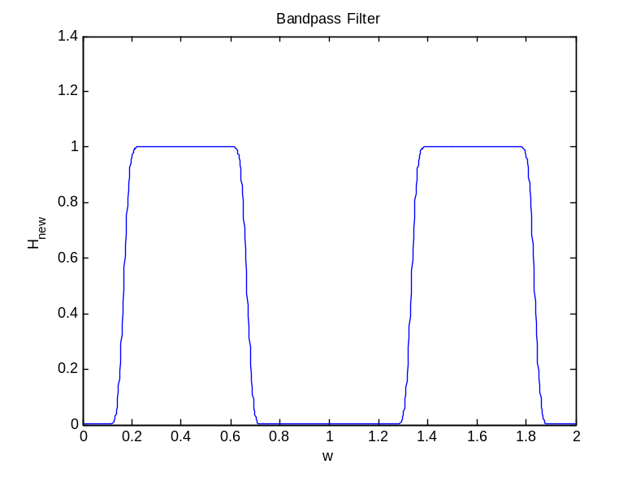
- Audio Examples:
  - Lowpass filtering problem:
  - Sketch the tolerances for 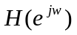for (in separate papers)
  - Window design (calculation in separate papers).
Zoomed plots showing amount of ripple and confirming that the design meets the specification at the pass/stop band edges.
Fig.2.13
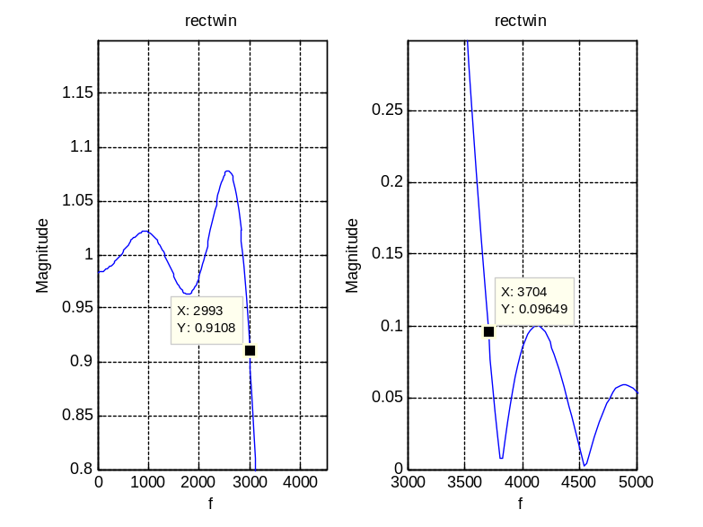
Delta1 = 0.0892 > 0.02. Delta2 = 0.09649 > 0.0032
Rectangular window does not meet the specification.
Fig.2.14
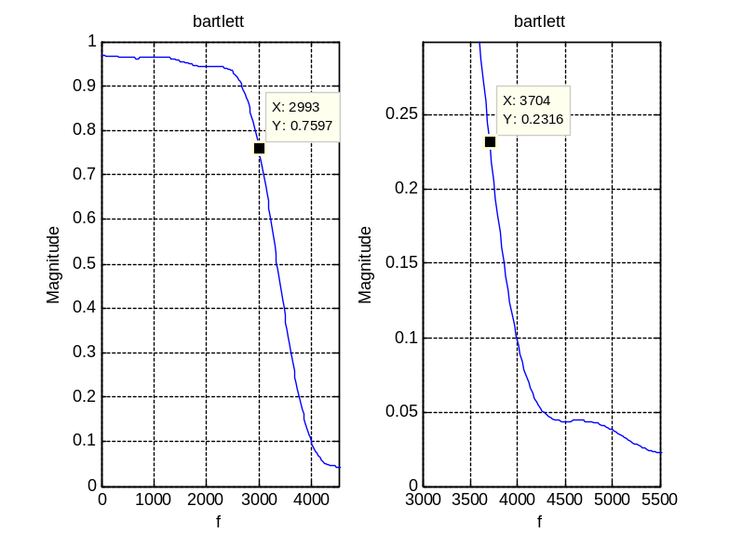
Delta1 = 0.2403 > 0.02. Delta2 = 0.2316 > 0.0032.
Bartlett window does not meet the specification.
Fig.2.15
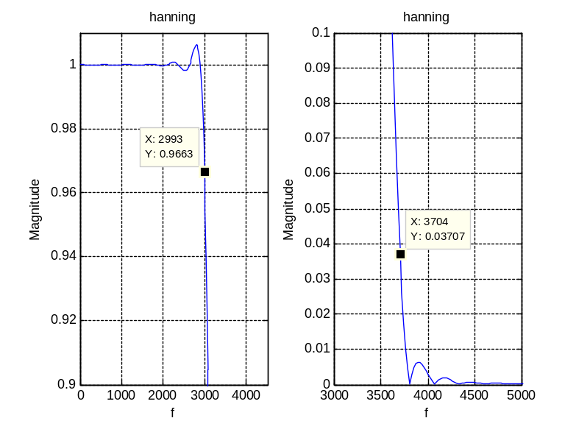
Delta1 = 0.0337 > 0.02. Delta2 = 0.3707 > 0.0032.
Hanning window does not meet the specification.
Fig.2.16
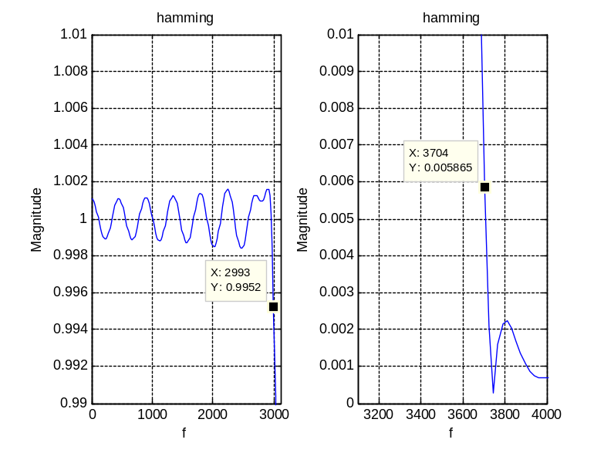
Delta1 = 0.0048 < 0.02. Delta2 = 0.005865 < 0.0032.
Hamming window meets the specification.
Fig.2.17
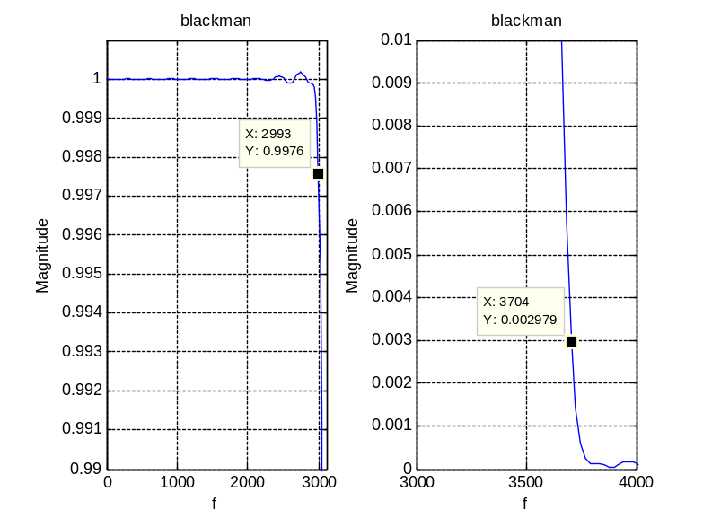
Delta1 = 0.0024 < 0.02. Delta2 = 0.002979 < 0.0032.
Blackman window meets the specification.
Fig.2.18. Phase characteristics of the 5 windows.
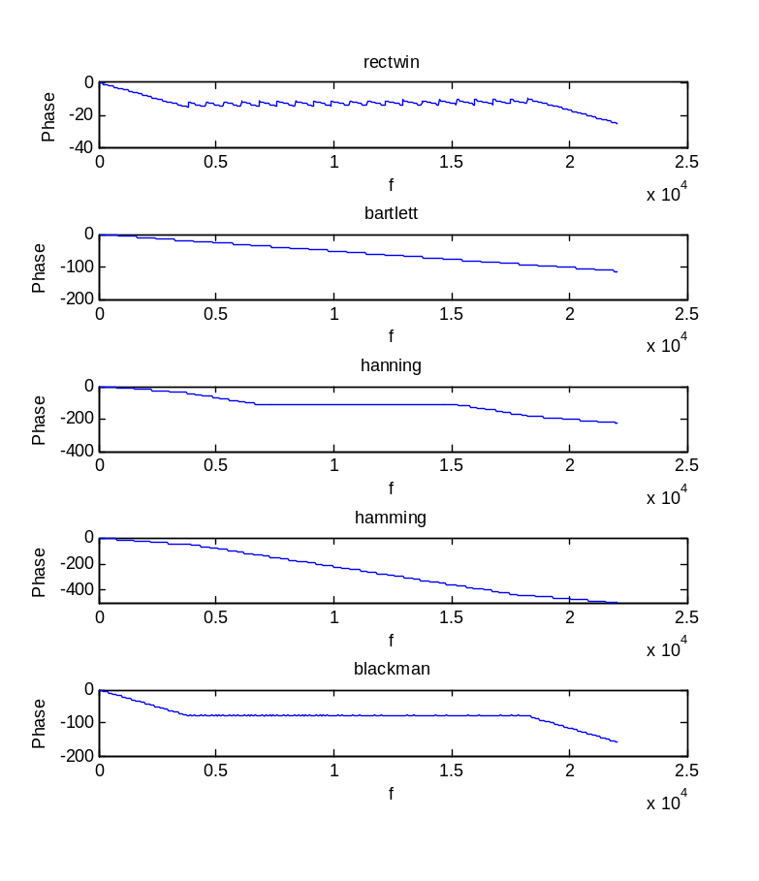
  - Application: Filtering the noisy audio signal.
- Load the noise signal (It says: "in this town we obey the law of thermal dynamic")
- Filter the signal with each of our 5 filters in part b.
Fig.2.19.
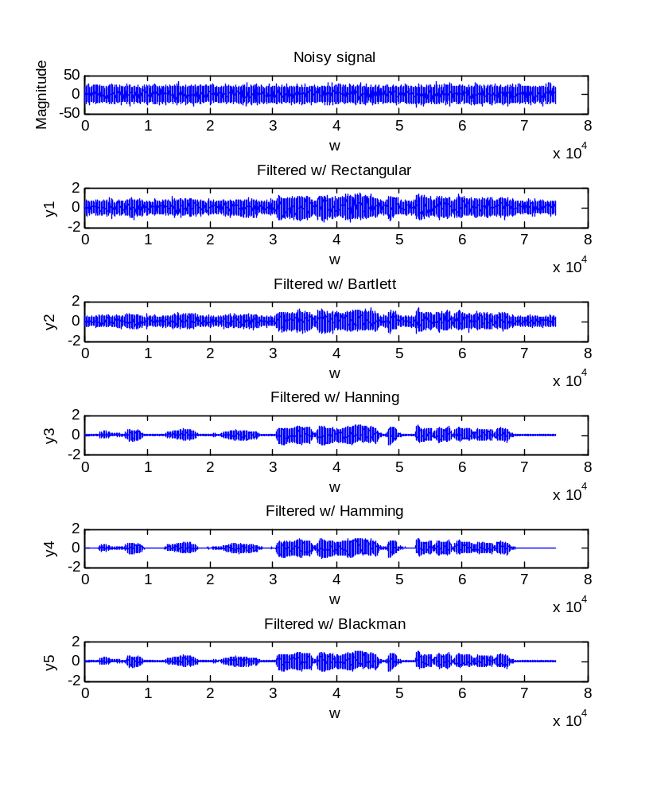
- The most sufficient filter is the Blackman filter. It removes almost all the noise out. The hamming, hanning, Bartlett and rectangular filters still have noticeable noise.
- Fig.2.19. contains the plots of the original signal and the filtered signals.
  - Audio Filterbank:
- Play the sound clip using the soundsc command (the short segment of Veni Sancte Spiritus).
- Design a set of filters with the following characteristics:
Filter 1: lowpass, passes all frequencies less than 220 Hz.
Filter 2: bandpass, passes frequencies between 220 and 440 Hz.
Filter 3: bandpass, passes frequencies between 440 and 880 Hz.
Filter 4: bandpass, passes frequencies between 880 and 1760 Hz.
Filter 5: bandpass, passes frequencies between 1760 and 3520 Hz.
Filter 6: highpass, passes frequencies above 3520 Hz.
(Matlab source code in the Appendix).
- Play the sound clip in the file with each of the filters.
The vocals are concentrated in the frequencies between 1760 and 3520 Hz.
- Conclusion:
This project is very helpful. It helps me to understand more about filters and how to design them. This is also a good chance to review some of the Matlab useful functions.
- Appendix:
This section contains all the Matlab source code for the above graphs.

%---------------------------------------------------------
% 2. FIR Filter Design via the Window method
%---------------------------------------------------------
%---------------------------------------------------------
% 2.b. Generate rectangular windows L=11,51,101
%---------------------------------------------------------
wrect11 = rectwin(11);
wrect51 = rectwin(51);
wrect101 = rectwin(101);
[W11, w11] = freqz(wrect11, 1, 1024, 'whole');
[W51, w51] = freqz(wrect51, 1, 1024, 'whole');
[W101, w101] = freqz(wrect101, 1, 1024, 'whole');
plot(w11/pi, abs(W11), 'b-', w51/pi, abs(W51), 'r--', w101/pi, abs(W101), 'g-.');
legend('11pts rectwin', '51pts rectwin', '101pts rectwin');
title('Frequency Response Magnitudes'); xlabel('w'); ylabel('W(e^{jw})');
axis([0 0.5 0 120]);
%---------------------------------------------------------
%% 2.c.i Impulse response of the 3 filters we defined
%---------------------------------------------------------
wc = pi/3;
M = [5 25 50];
inc = 1;
for i=1:3
n1 = -M(i):inc:-inc;
n2 = inc:inc:M(i);
n0 = 0;
h_n1 = sin(wc*n1)./(pi*n1);
h_lhopital = wc*cos(wc*n0)/pi;
h_n2 = sin(wc*n2)./(pi*n2);
h = [h_n1 h_lhopital h_n2];
n = -M(i):inc:M(i);
figure(2);
subplot(3,1,i);
stem(n, h);
title(['h_',num2str(i),'[n] with ',num2str(M(i)*2+1),' pts']); xlabel('n'); ylabel('h[n]');
%---------------------------------------------------------
% 2.c.ii Frequency response of the 3 filters
%---------------------------------------------------------
figure(3);
subplot(3,1,i);
[H, w] = freqz(h, 1, 1024, 'whole');
plot(w/pi, abs(H));
title(['H_',num2str(i),' with ',num2str(M(i)*2+1),' pts']); xlabel('w'); ylabel('H(e^{jw})');
end
%---------------------------------------------------------
%% 2.d.i Generate 3 blackman windows L=11,51,101
%---------------------------------------------------------
n11 = -5:5;
wblkman11 = blackman(11);
n51 = -25:25;
wblkman51 = blackman(51);
n101 = -50:50;
wblkman101 = blackman(101);
figure(4);
subplot(3,1,1);
stem(n11, wblkman11);
title('Blackman window L=11');xlabel('n');ylabel('w');
subplot(3,1,2);
stem(n51, wblkman51);
title('Blackman window L=51');xlabel('n');ylabel('w');
subplot(3,1,3);
stem(n101, wblkman101);
title('Blackman window L=101');xlabel('n');ylabel('w');
%---------------------------------------------------------
% 2.d.ii Frequency response Magnitude of 3 blackman windows
%---------------------------------------------------------
[Wbm11, w11] = freqz(wblkman11, 1, 1024, 'whole');
[Wbm51, w51] = freqz(wblkman51, 1, 1024, 'whole');
[Wbm101, w101] = freqz(wblkman101, 1, 1024, 'whole');
figure(5);
subplot(3,1,1);
plot(w11/pi, 10*log10(abs(Wbm11)));
title('Blackman Freq. Resp. Magnitudes L=11'); xlabel('w'); ylabel('20log10(abs(W))');
subplot(3,1,2);
plot(w51/pi, 10*log10(abs(Wbm51)));
title('Blackman Freq. Resp. Magnitudes L=51'); xlabel('w'); ylabel('20log10(abs(W))');
subplot(3,1,3);
plot(w101/pi, 10*log10(abs(Wbm101)));
title('Blackman Freq. Resp. Magnitudes L=101'); xlabel('w'); ylabel('20log10(abs(W))');
%---------------------------------------------------------
%% 2.d.iii Blackman lowpass filter wc=pi/3
%---------------------------------------------------------
wc = pi/3;
M = [5 25 50];
inc = 1;
for i=1:3
n1 = -M(i):inc:-inc;
n2 = inc:inc:M(i);
n0 = 0;
h_n1 = sin(wc*n1)./(pi*n1);
h_lhopital = wc*cos(wc*n0)/pi;
h_n2 = sin(wc*n2)./(pi*n2);
hlpf = [h_n1 h_lhopital h_n2];
n = [n1 n0 n2];
wbm = blackman(M(i)*2+1);
h = wbm'.*hlpf;
[H, w] = freqz(h, 1, 1024, 'whole');
subplot(3,1,i);
plot(w/pi, abs(H));
title(['Blackman H_',num2str(i),' with ',num2str(M(i)*2+1),' pts']); xlabel('w'); ylabel('H(e^{jw})');
end
%---------------------------------------------------------
% 2.e Lowpass filter function
%---------------------------------------------------------
function [h,n] = fir_lpf(wc, M, winfxn)
% Function to implement window design of lowpass filters
% wc : cutoff frequency
% M : integer that defines the length of the filter L = 2*M + 1
% winfxn : a string which contains the name of the window function to use
% example: @blackman, @hamming, ...
% notice the '@' right infront of each function name
n1 = -M:-1;
n2 = 1:M;
n0 = 0;
L = 2*M+1;
h_n1 = sin(wc*n1)./(pi*n1);
h_lhopital = wc*cos(wc*n0)/pi;
h_n2 = sin(wc*n2)./(pi*n2);
hlpf = [h_n1 h_lhopital h_n2];
n = [n1 n0 n2];
w = feval(winfxn, L);
h = w'.*hlpf;
plot(n, h);
%---------------------------------------------------------
%% 3.c
%---------------------------------------------------------
wc = pi/4;
[h, n] = fir_lpf(wc, 50, @blackman);
hnew = h.*cos(pi*n);
[Hnew, w] = freqz(hnew, 1, 1024, 'whole');
plot(w/pi, abs(Hnew));
title('Freq. Resp.'); xlabel('w'); ylabel('H_{new}');
%---------------------------------------------------------
%% 3.d.ii & iii Design a bandpass filter
%---------------------------------------------------------
wc = pi/4;
[h, n] = fir_lpf(wc, 50, @blackman);
hnew = h.*cos(5*pi*n/12)*2;
figure;
plot(n, hnew);
title('Impulse Resp.'); xlabel('n'); ylabel('h');
[Hnew, w] = freqz(hnew, 1, 1024, 'whole');
figure;
plot(w/pi, abs(Hnew));
title('Bandpass Filter'); xlabel('w'); ylabel('H_{new}');
%---------------------------------------------------------
%% 4.1.b Window design
%---------------------------------------------------------
wc = 0.304*pi;
fs = 22050;
% filter 1
[h1, n1] = fir_lpf(wc, 14, @rectwin);
[H1, f1] = freqz(h1, 1, 1024, 'whole', fs);
figure;
subplot(1,2,1);
plot(f1, abs(H1));grid;
axis([0 4500 0.8 1.2]);
title('rectwin'); xlabel('f'); ylabel('Magnitude');
subplot(1,2,2);
plot(f1, abs(H1));grid;
axis([3000 5000 0 0.3]);
title('rectwin'); xlabel('f'); ylabel('Magnitude');
% filter 2
[h2, n2] = fir_lpf(wc, 18, @bartlett);
[H2, f2] = freqz(h2, 1, 1024, 'whole', fs);
figure;
subplot(1,2,1);
plot(f2, abs(H2));grid;
axis([0 4500 0 1]);
title('bartlett'); xlabel('f'); ylabel('Magnitude');
subplot(1,2,2);
plot(f2, abs(H2));grid;
axis([3000 5500 0 0.3]);
title('bartlett'); xlabel('f'); ylabel('Magnitude');
% filter 3
[h3, n3] = fir_lpf(wc, 39, @hanning);
[H3, f3] = freqz(h3, 1, 1024, 'whole', fs);
figure;
subplot(1,2,1);
plot(f3, abs(H3));grid;
axis([0 4500 0.9 1.01]);
title('hanning'); xlabel('f'); ylabel('Magnitude');
subplot(1,2,2);
plot(f3, abs(H3));grid;
axis([3000 5000 0 0.1]);
title('hanning'); xlabel('f'); ylabel('Magnitude');
% filter 4
[h4, n4] = fir_lpf(wc, 49, @hamming);
[H4, f4] = freqz(h4, 1, 1024, 'whole', fs);
figure;
subplot(1,2,1);
plot(f4, abs(H4));grid;
axis([0 3100 0.99 1.01]);
title('hamming'); xlabel('f'); ylabel('Magnitude');
subplot(1,2,2);
plot(f4, abs(H4));grid;
axis([3100 4000 0 0.01]);
title('hamming'); xlabel('f'); ylabel('Magnitude');
% filter 5
[h5, n5] = fir_lpf(wc, 72, @blackman);
[H5, f5] = freqz(h5, 1, 1024, 'whole', fs);
figure;
subplot(1,2,1);
plot(f5, abs(H5));grid;
axis([0 3100 0.99 1.001]);
title('blackman'); xlabel('f'); ylabel('Magnitude');
subplot(1,2,2);
plot(f5, abs(H5));grid;
axis([3000 4000 0 0.01]);
title('blackman'); xlabel('f'); ylabel('Magnitude');
%---------------------------------------------------------
%% 4.1.c.i
%---------------------------------------------------------
load noisysig.mat;
soundsc(xnoisy, fs);
% It's a male cartoon voice but there were a lot of noise.
%---------------------------------------------------------
%% 4.1.c.ii Filter the signal w/ our filters
%---------------------------------------------------------
y1 = filter(h1, 1, xnoisy);
y2 = filter(h2, 1, xnoisy);
y3 = filter(h3, 1, xnoisy);
y4 = filter(h4, 1, xnoisy);
y5 = filter(h5, 1, xnoisy);
subplot(6,1,1);
plot(xnoisy);
title('Noisy signal'); xlabel('w'); ylabel('Magnitude');
subplot(6,1,2);
plot(y1);
title('Filtered w/ Rectangular'); xlabel('w'); ylabel('y1');
subplot(6,1,3);
plot(y2);
title('Filtered w/ Bartlett'); xlabel('w'); ylabel('y2');
subplot(6,1,4);
plot(y3);
title('Filtered w/ Hanning'); xlabel('w'); ylabel('y3');
subplot(6,1,5);
plot(y4);
title('Filtered w/ Hamming'); xlabel('w'); ylabel('y4');
subplot(6,1,6);
plot(y5);
title('Filtered w/ Blackman'); xlabel('w'); ylabel('y5');
%---------------------------------------------------------
%% 4.1.c.iii
%---------------------------------------------------------
%% rectangular
soundsc(y1, fs); % still has lot of noise
%% bartlett
soundsc(y2, fs); % a bit less noise as compare to the rectangular
%% hanning
soundsc(y3, fs); % still noise but it's small
%% hamming
soundsc(y4, fs); % still noise but it's small
%% blackman
soundsc(y5, fs); % all noises are filtered
% It says: "in this town we obey the law of thermal dynamic"
%---------------------------------------------------------
%% 4.1.c.iv
%---------------------------------------------------------
% done above

%---------------------------------------------------------
%% 4.2.a Play the clip
%---------------------------------------------------------
load proj2_clip.mat
soundsc(clip, Fs);
%---------------------------------------------------------
%% Bandpass function
%---------------------------------------------------------
function [h, n] = bandpass(fl, fh, fs, M, winfxn)
% produce a band pass impulse response
% fl,fh : left and right cutoff frequency (Hz)
% fs : sampling frequency
% M : L=M*2+1: window length
% winfxn : a string of window function name
wh = 2*pi*fh/fs;
wl = 2*pi*fl/fs;
wc = (wh-wl)/2;
w0 = wc+wl;
[hlpf, n] = fir_lpf(wc, M, winfxn);
h = hlpf.*cos(w0*n)*2;
%---------------------------------------------------------
%% Highpass function
%---------------------------------------------------------
function [h, n] = highpass(f, fs, M, winfxn)
% produce a high pass impulse response
% f : cutoff frequency (Hz)
% fs : sampling frequency
% M : L=M*2+1: window length
% winfxn : a string of window function name
wc = pi-2*pi*f/fs;
[hlpf, n] = fir_lpf(wc, M, winfxn);
h = hlpf.*cos(pi*n);
%---------------------------------------------------------
%% 4.2.b Design lowpass, bandpass and highpass filters
%---------------------------------------------------------
M = 100;
% filter 1
[f1, n] = fir_lpf(2*pi*220/Fs, M, @blackman);
[F1, w] = freqz(f1, 1, 1024, 'whole', Fs);
figure;
plot(w, abs(F1));
% filter 2
[f2, n] = bandpass(220, 440, Fs, M, @blackman);
[F2, w] = freqz(f2, 1, 1024, 'whole', Fs);
figure;
plot(w, abs(F2));
% filter 3
[f3, n] = bandpass(440, 880, Fs, M, @blackman);
[F3, w] = freqz(f3, 1, 1024, 'whole', Fs);
figure;
plot(w, abs(F3));
% filter 4
[f4, n] = bandpass(880, 1760, Fs, M, @blackman);
[F4, w] = freqz(f4, 1, 1024, 'whole', Fs);
figure;
plot(w, abs(F4));
% filter 5
[f5, n] = bandpass(1760, 3520, Fs, M, @blackman);
[F5, w] = freqz(f5, 1, 1024, 'whole', Fs);
figure;
plot(w/pi, abs(F5));
% filter 6
[f6, n] = highpass(3520, Fs, M, @blackman);
[F6, w] = freqz(f6, 1, 1024, 'whole', Fs);
figure;
plot(w, abs(F6));
%---------------------------------------------------------
%% 4.2.c Filter the sound clip w/ the above filters then play them
%---------------------------------------------------------
soundsc(clip, Fs);
%% lower pass filter 220Hz
yf1 = filter(f1, 1, clip);
soundsc(yf1, Fs);
%% bandpass 220Hz-440Hz
yf2 = filter(f2, 1, clip);
soundsc(yf2, Fs);
%% bandpass 440-880Hz
yf3 = filter(f3, 1, clip);
soundsc(yf2, Fs);
%% bandpass 880-1760Hz
yf4 = filter(f4, 1, clip);
soundsc(yf2, Fs);
%% bandpass 1760-3520Hz
yf5 = filter(f5, 1, clip);
soundsc(yf5, Fs);
%% highpass 3520Hz
yf6 = filter(f6, 1, clip);
soundsc(yf6, Fs);

